Marko Shaffer

Information Security, Franklin University

ISEC 325: Comm/Network Security

Professor Rick Rozzell

6 / 6 / 2021

**Lab 03: Reconnaissance with**

**Nmap, Zenmap, and Masscan**

**&**

**Lab 04: Reconnaissance with**

**Hping**

# Instructions

Follow the instructions from “Lab 03: Reconnaissance with Nmap, Zenmap, and Masscan” and “Lab 04: Reconnaissance with Hping.”

* **Note:** For all of the screenshots in the following steps, make sure to include the entire browser window to show that you are logged in to Netlab.

# LAB 03: RECONNAISSANCE WITH NMAP, ZENMAP, AND MASSCAN

## Lab 03 - Section 1 - Reconnaissance Using Nmap

* Capture screenshots of the following:

### **Step 11 output**

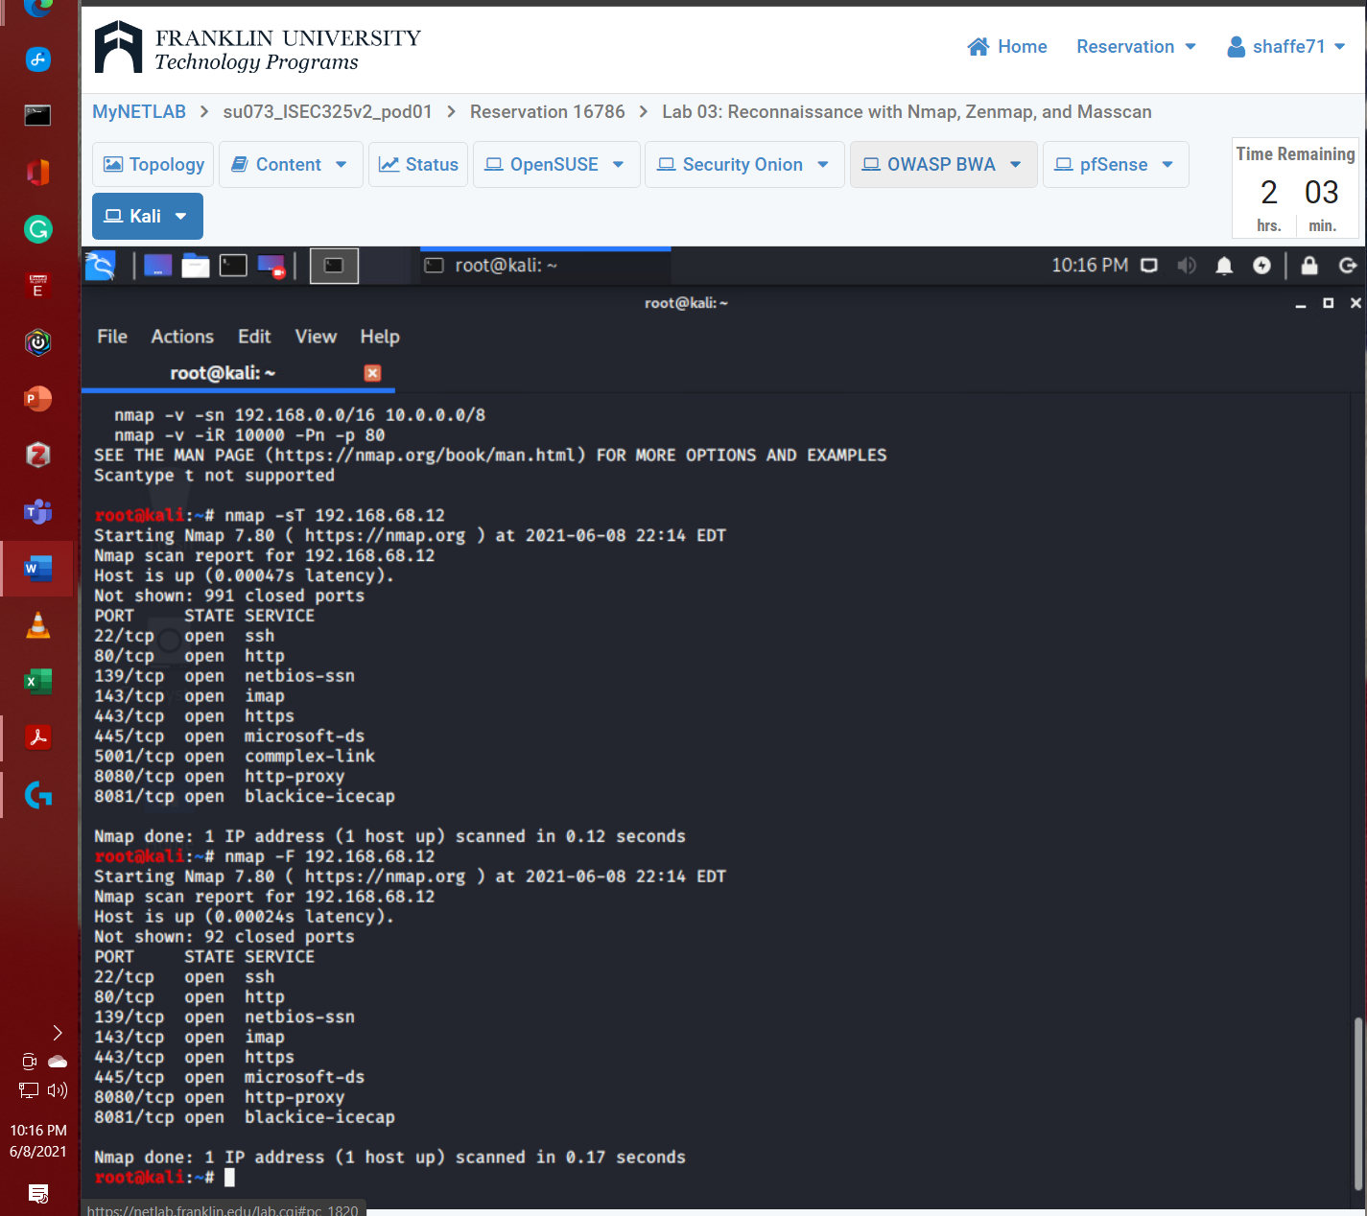

### **Step 12 output**

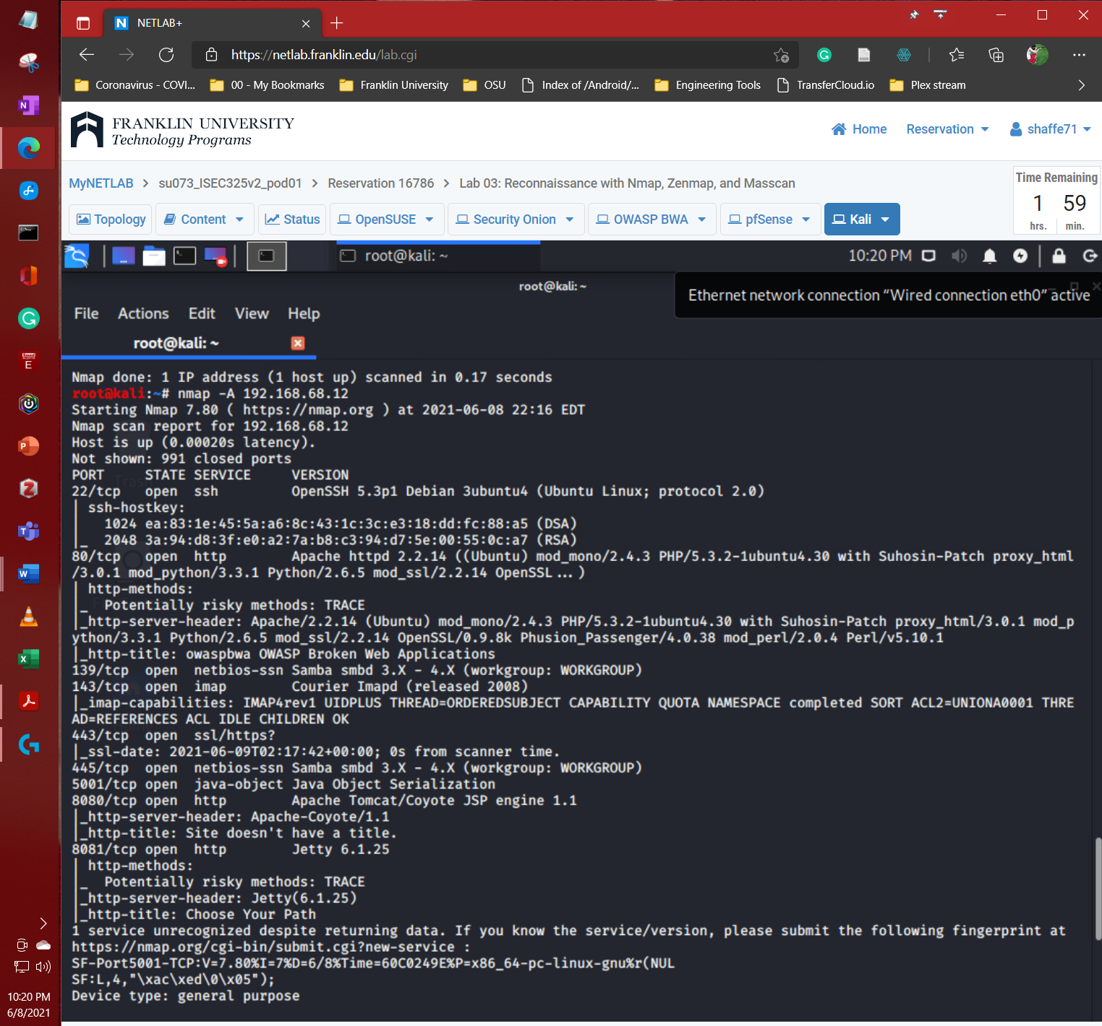

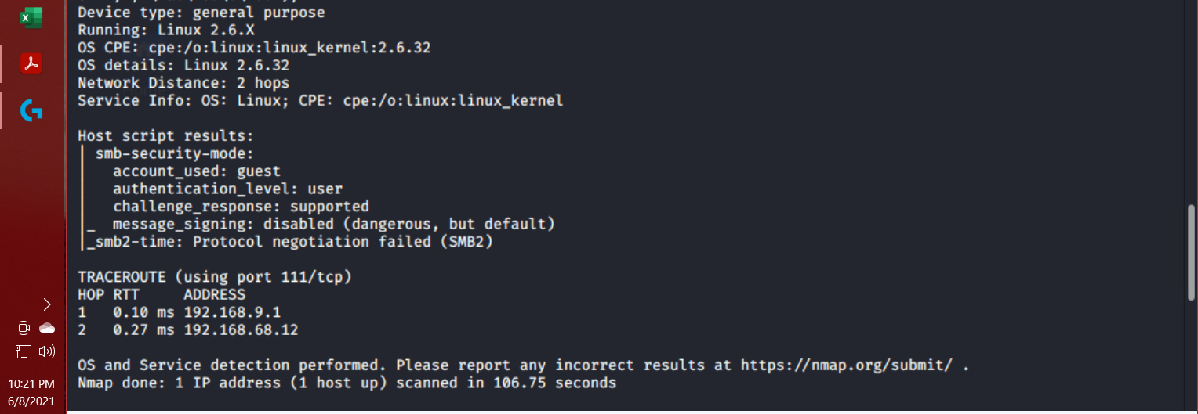

### **Step 13 output**

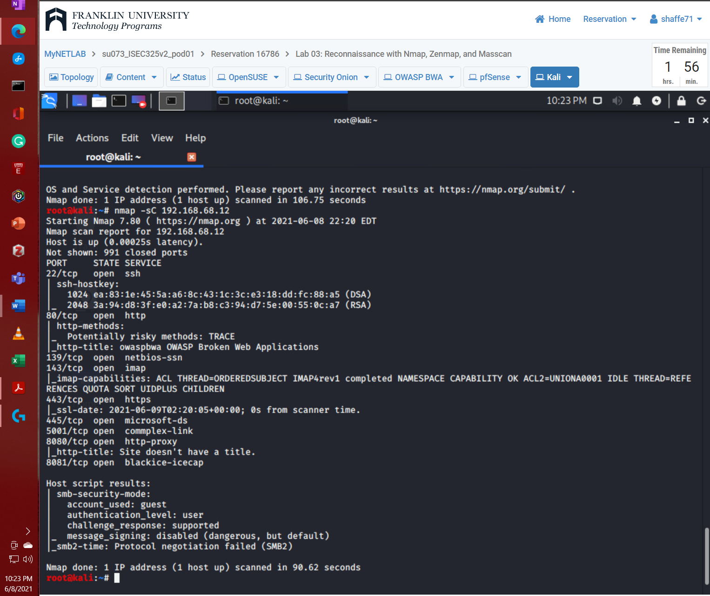

## Lab 03 - Section 2 - Using Amap for Reconnaissance

* Capture screenshots of the following:

### **Step 3 output**

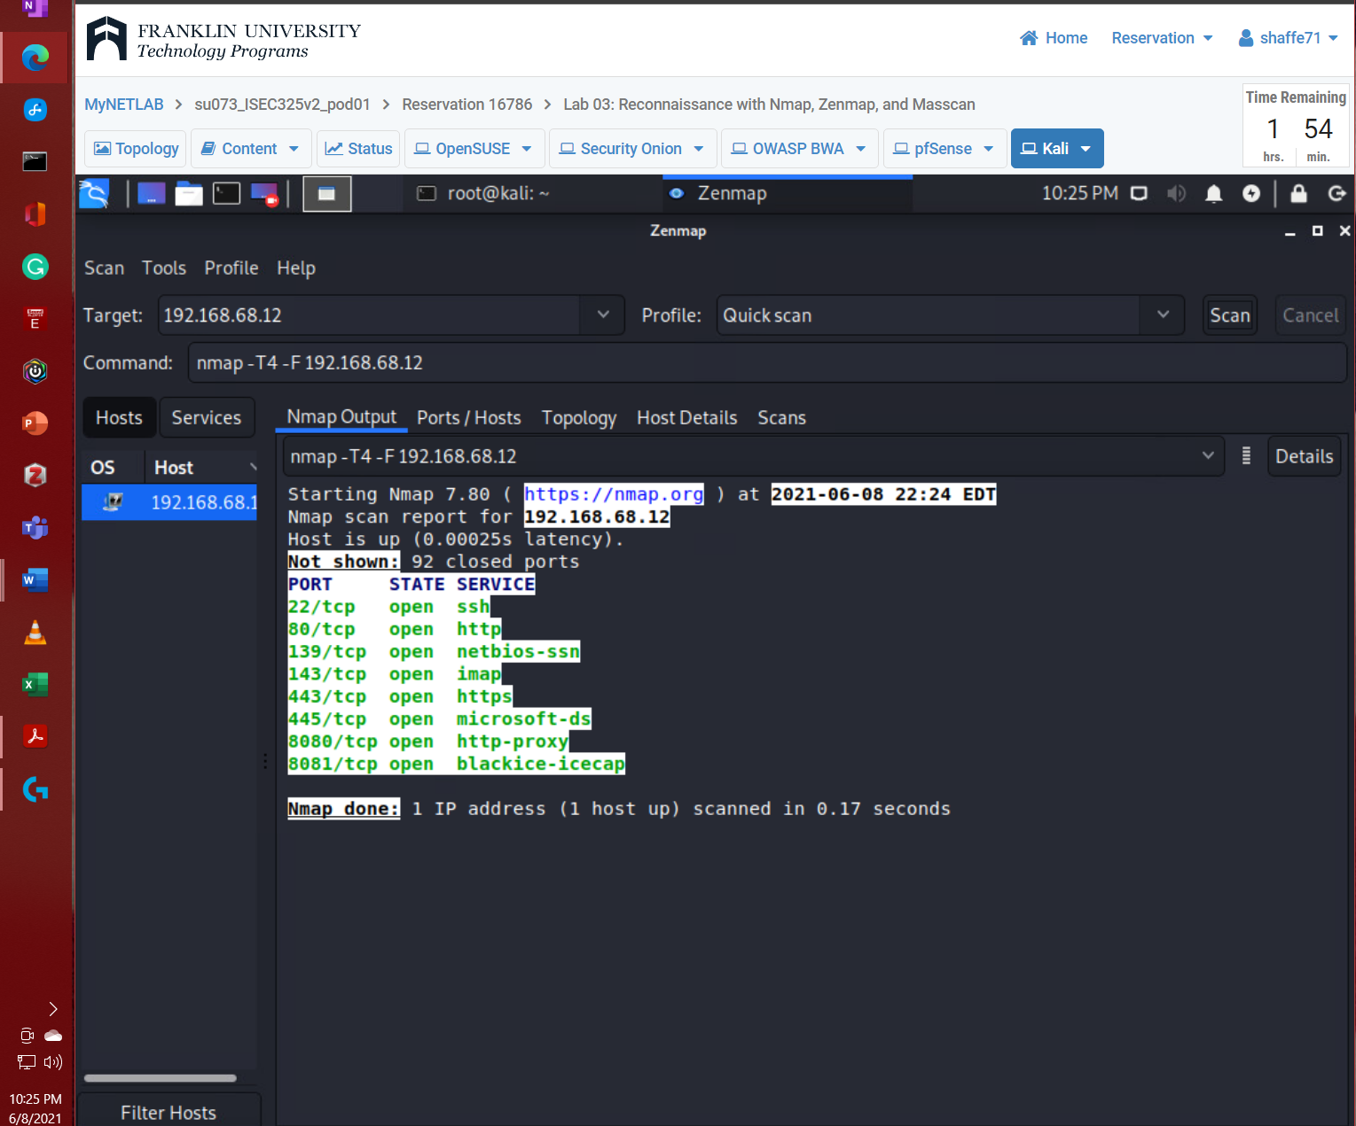

### **Step 8 output**

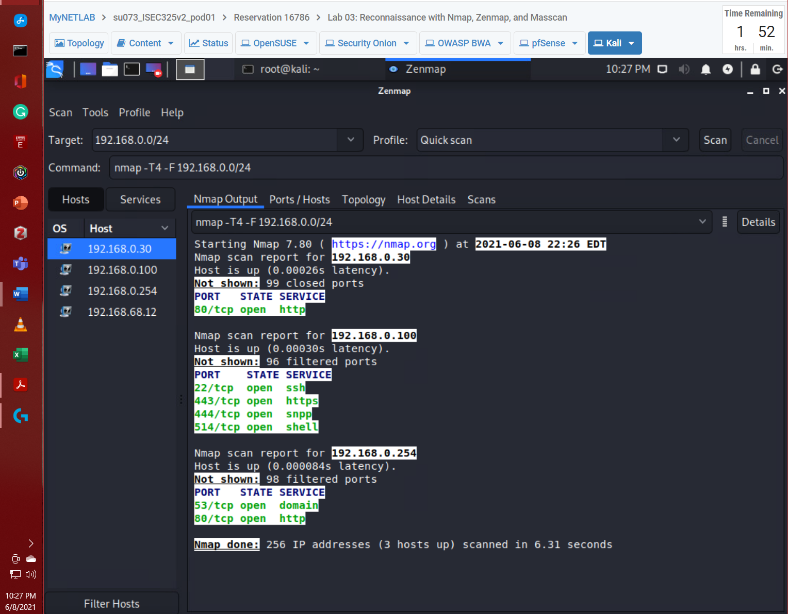

### **Step 9 output**

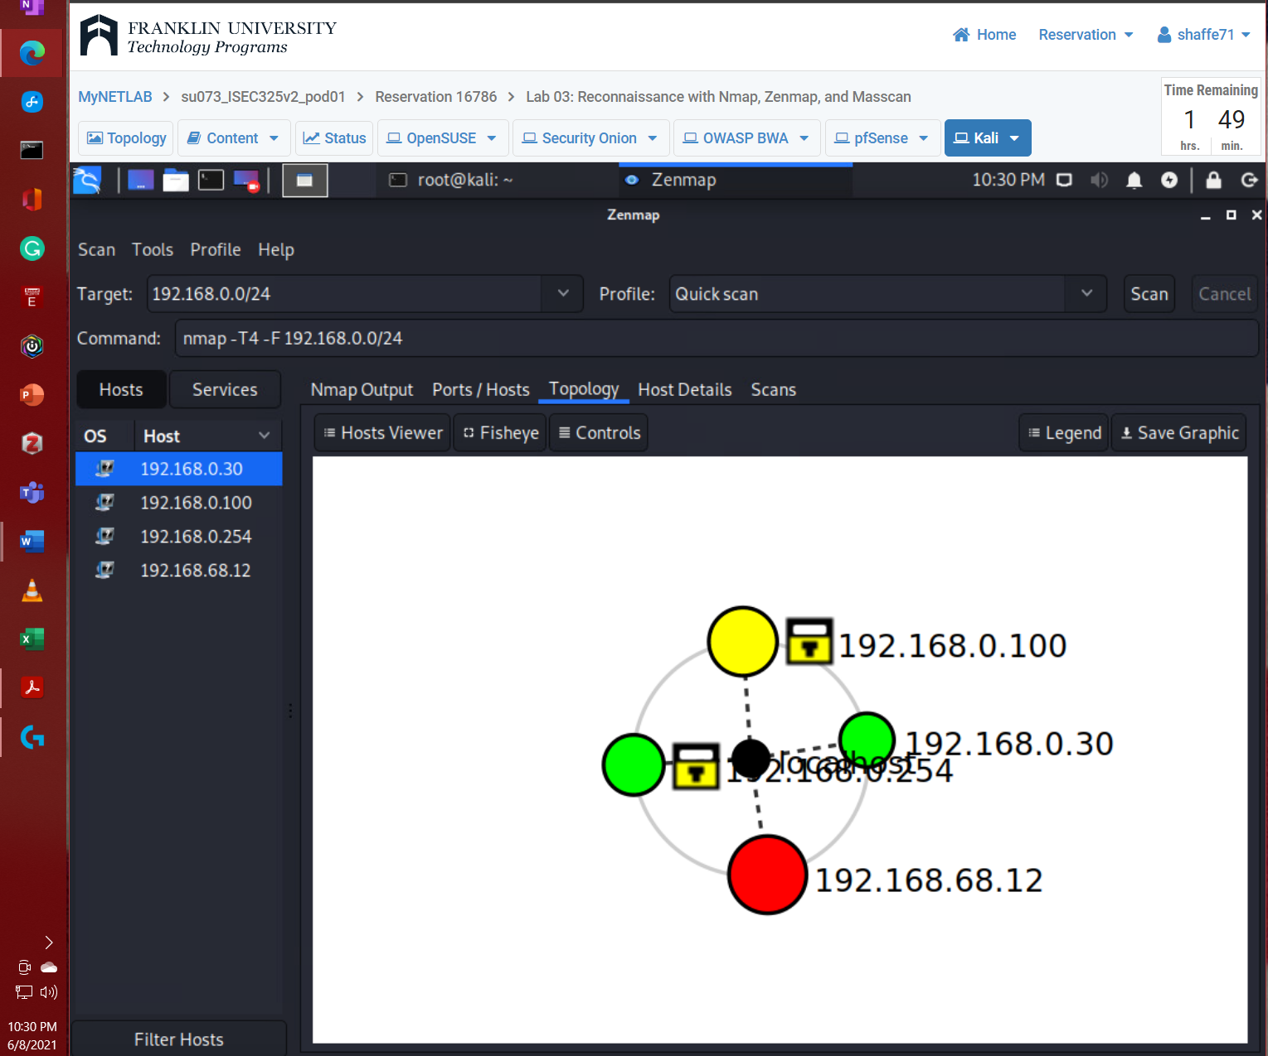

## Lab 03 - Section 3 - Reconnaissance Using Masscan

* Capture a screenshot of the following:

### **Step 4 output**

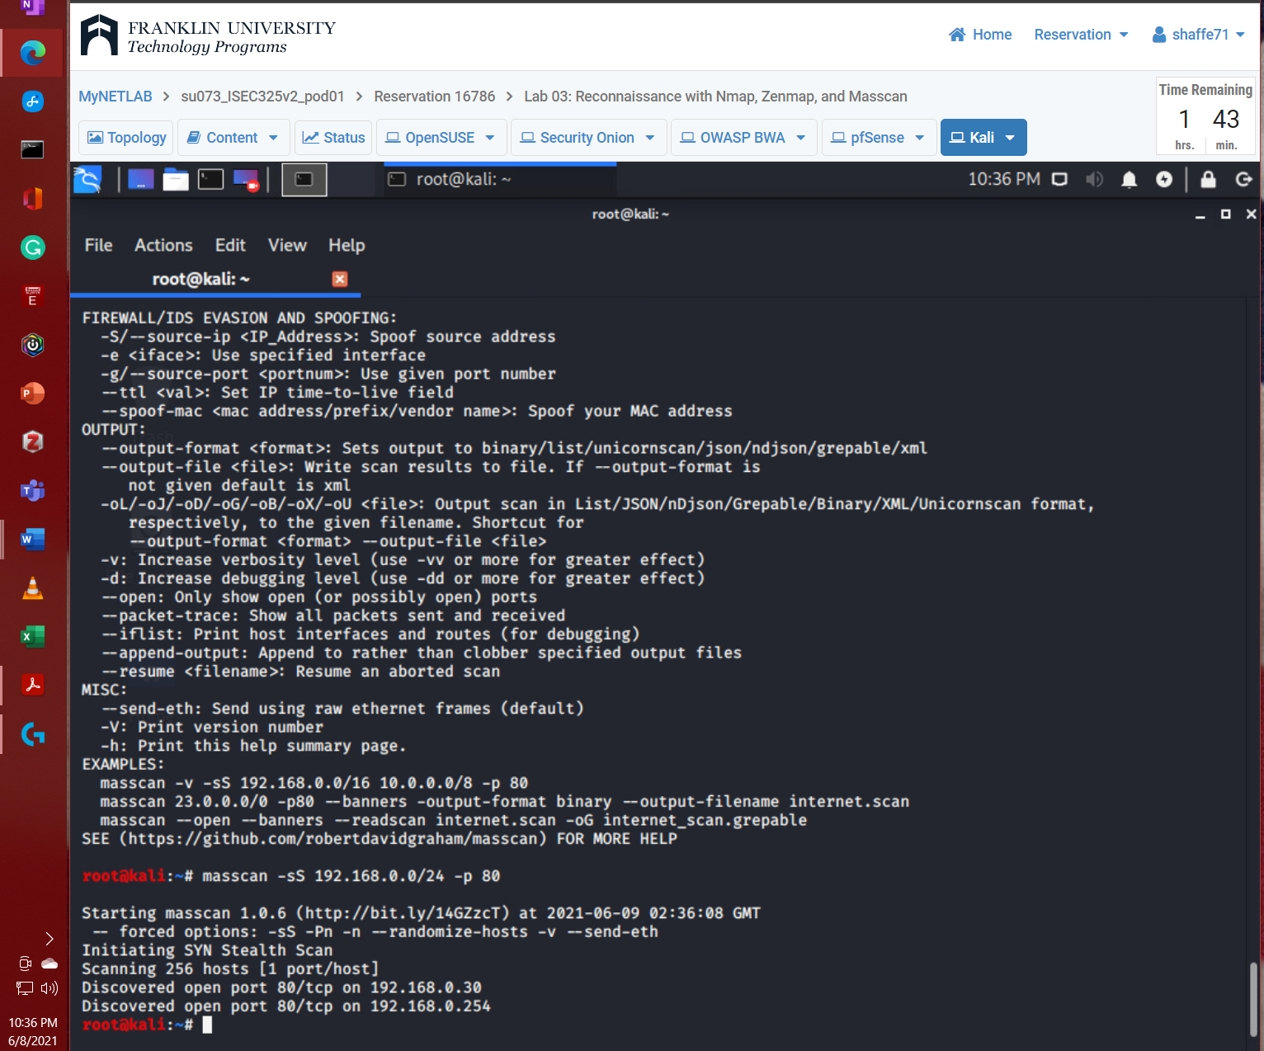

# Lab 04: RECONNAISSANCE WITH HPING

## Lab 04 - Section 1 - Using Hping as an ICMP utility

* Capture screenshots of the following:

### **Step 7 output**

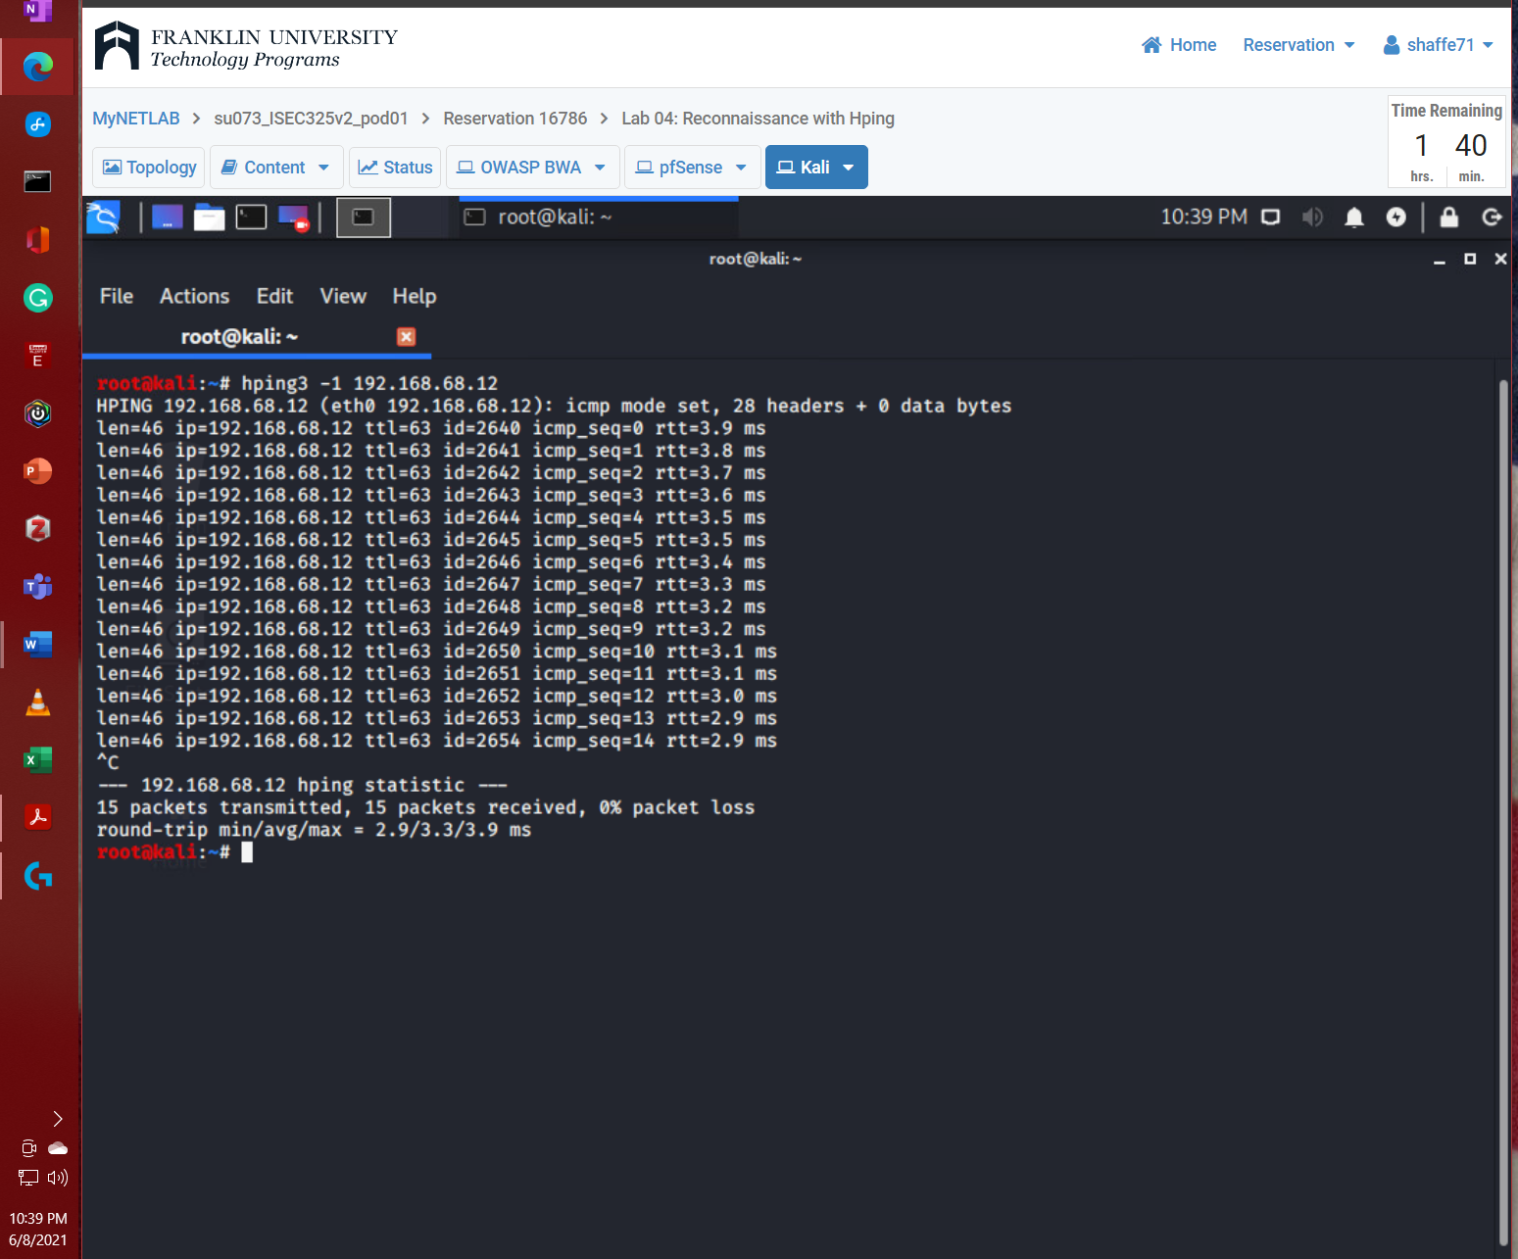

### **Step 8 output**

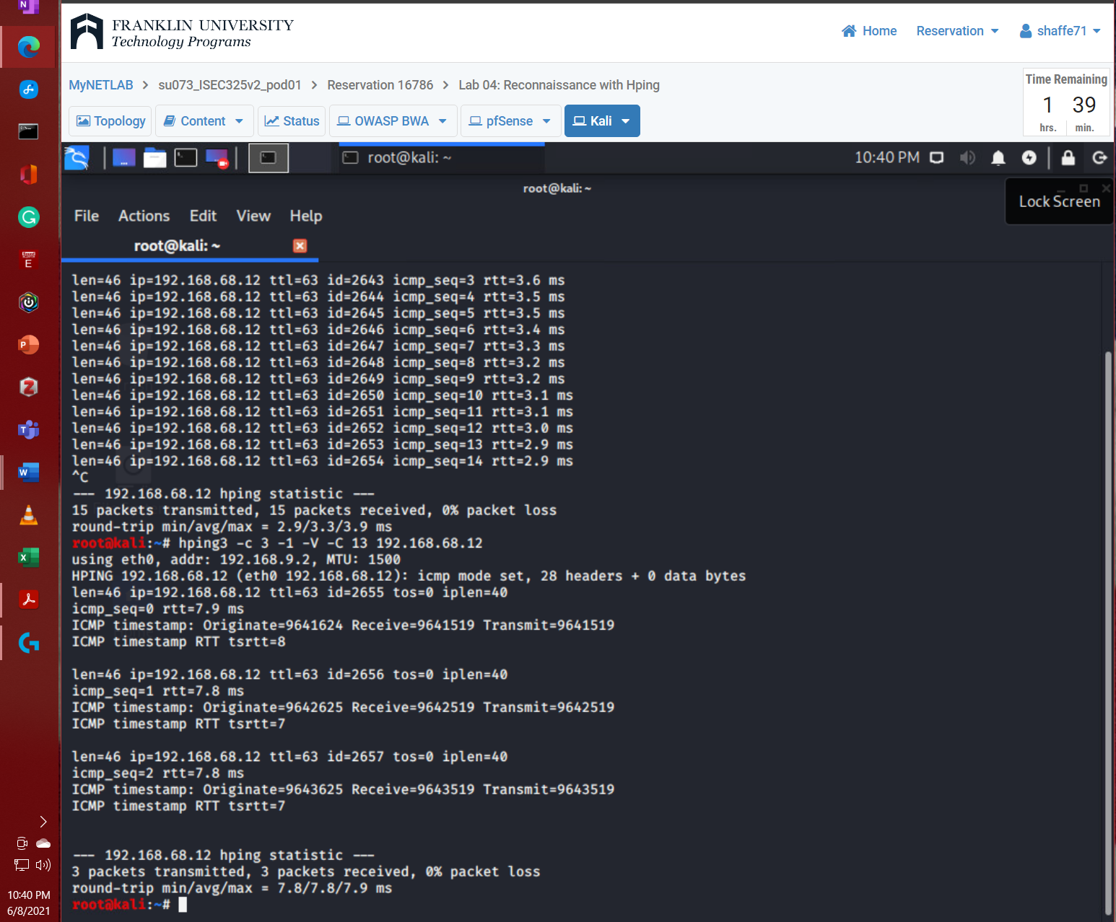

### **Step 9 output**

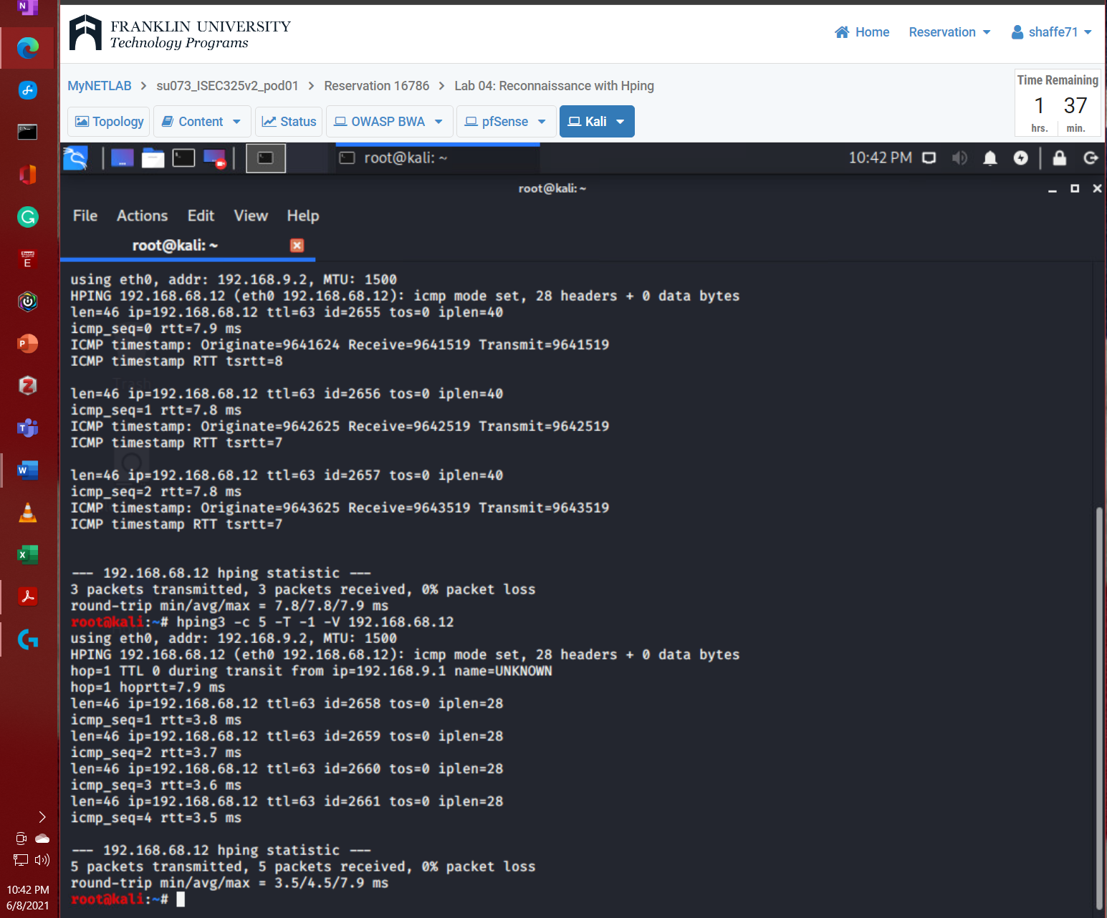

## Lab 04 - Section 2 - Using Hping for Port Scanning

* Capture screenshots of the following:
  1. **Step 5 output**

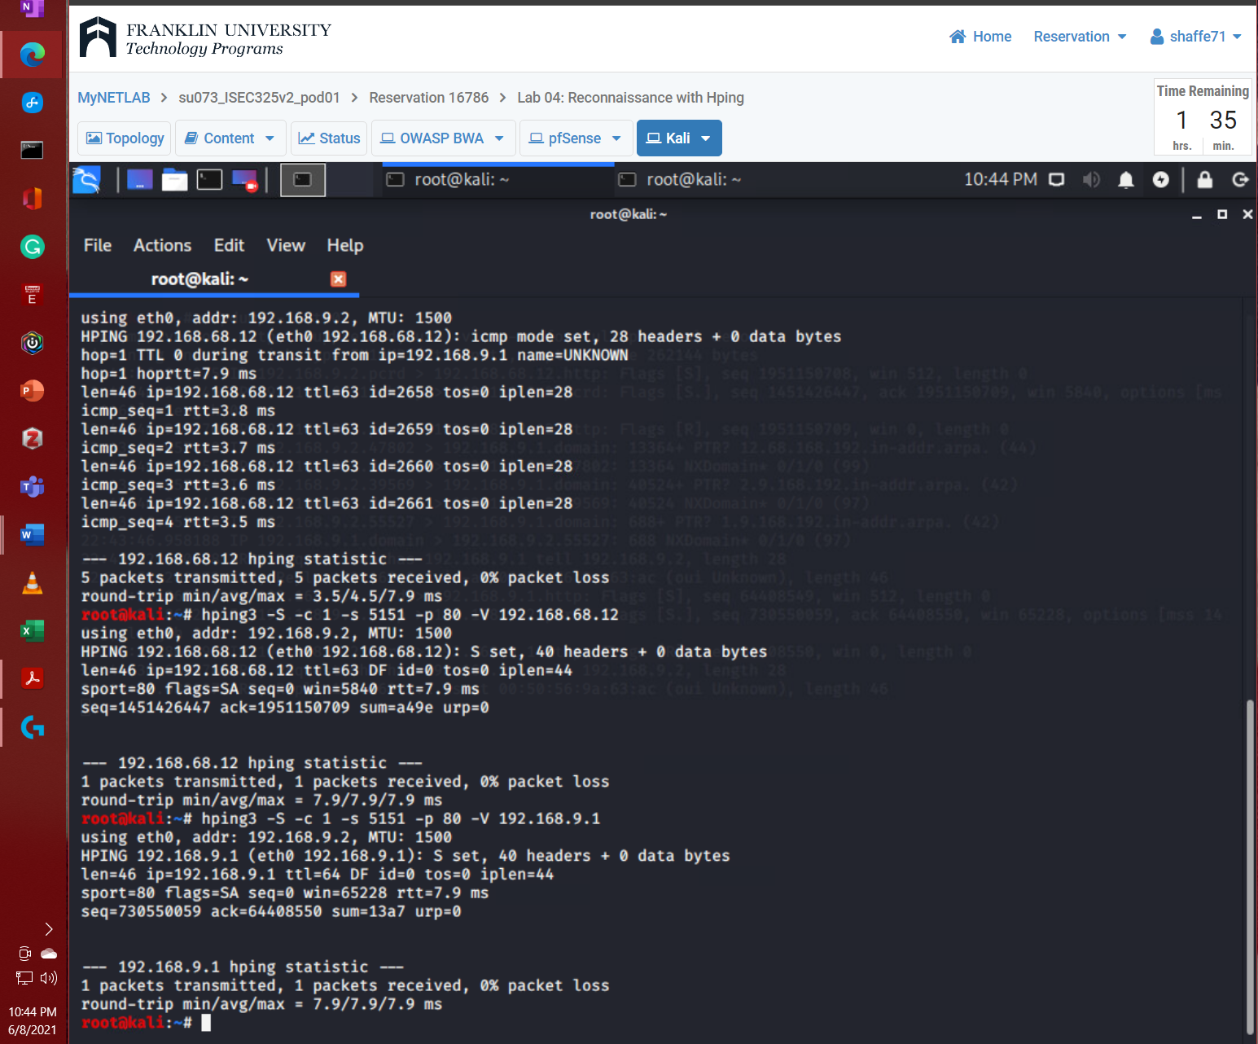

* 1. **Step 7 output**

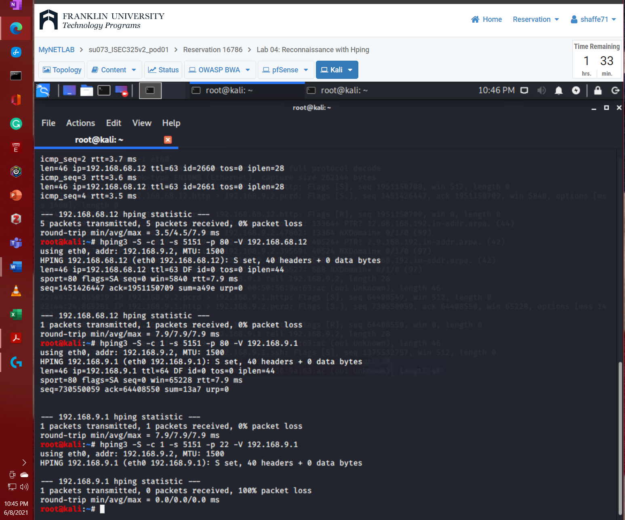

* 1. **Step 8 output**

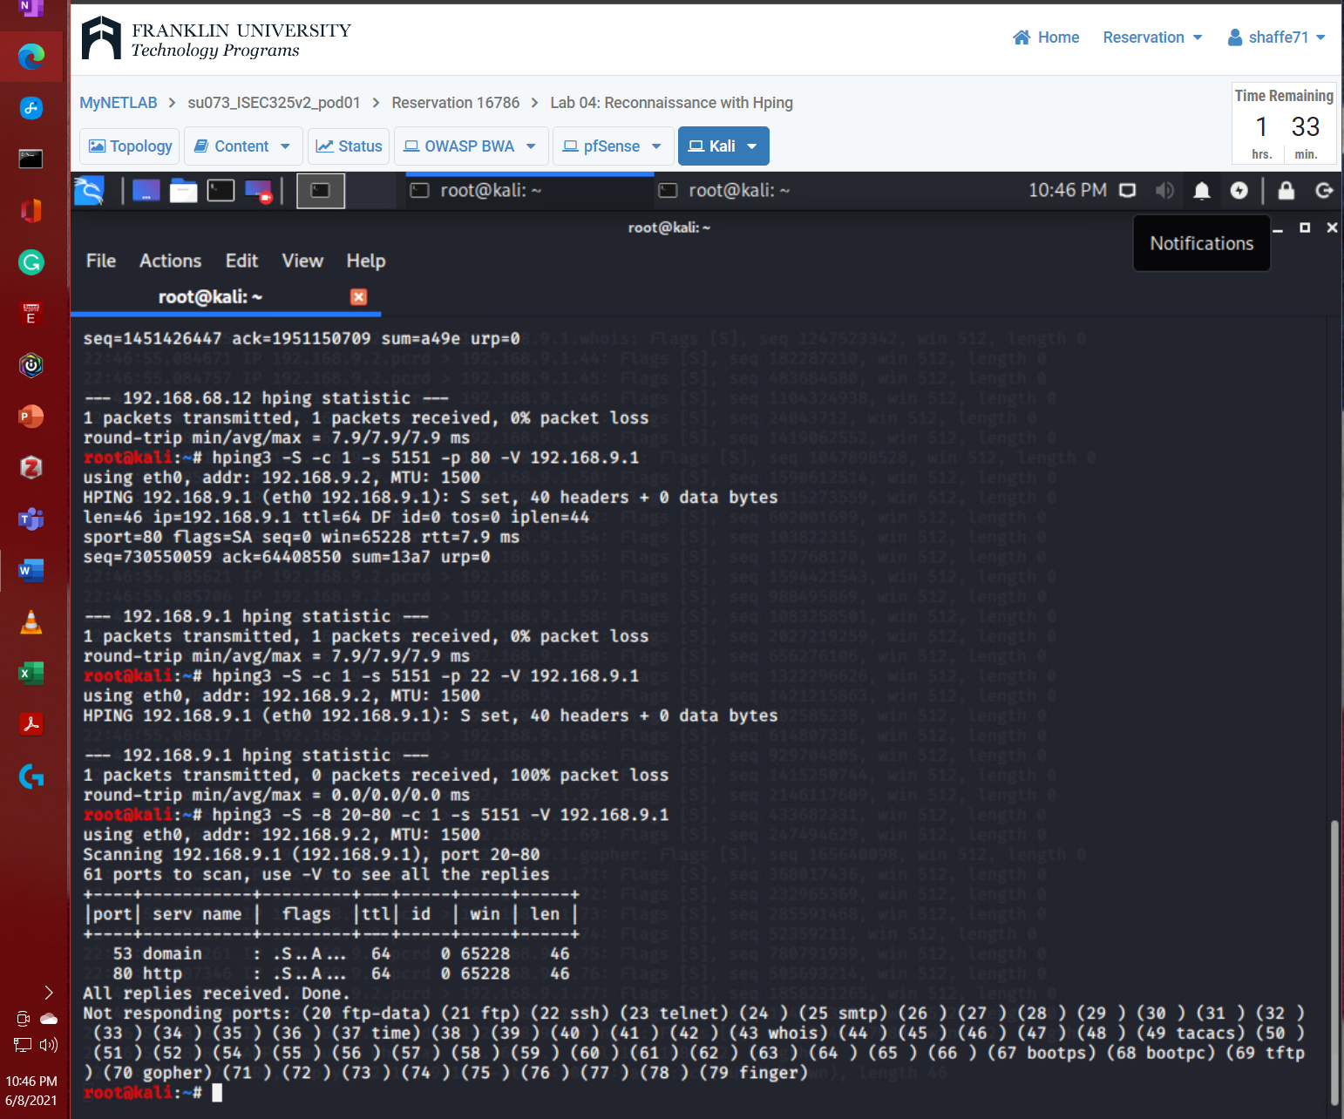

# Summary and Reflection:

## In a few paragraphs, reflect on what you learned through this lab assignment. Was there anything surprising or unexpected? Was there anything worth investigating further?

Labs 3 and 4 covered reconnaissance through several tools like Nmap, Zenmap, Masscan, and Hping provided in Kali Linux operating system.

Nmap is an open-source network mapping tool that runs from the shell command line. Nmap can reconnaissance of open ports for a specific IP address and specify the type of transfer protocol. The downside of Nmap is not vary stealthy. To combat this, they give you the option to specify -F to tell Nmap only to scan the most common ports. Another option is to attempt to identify the software version being used by the open ports through -A switch command. The last thing covered with Nmap is that they provide scripts that automatically scans for common vulnerabilities to speed up your reconnaissance. Zenmap is a GUI interface for Nmap and thus provides most of the same information. There are a few excellent features that Zenmap provides. The first is that it can provide a visual repetition of the Topology of the network being scanned. The second is that it provides a clean, easy-to-read output for the commands used in Nmap in the shell. Like Nmap and Zenmap, Masscan is also a port scanner for the internal network, but its expanses to Internet packet scanning. Masscan uses the TCP SYN technique to scan for internet packets. I would be interested in understanding Masscan and what more it can do since I have used Nmap and Zenmap before.

Lab 4 covered Hping, a shell command line tool focusing on TCP/IP packet analyzing. Hping can ping an IP address using the specified protocol to see if they are receiving packets for a specific protocol, and a possible connection can be made. Hping also allows for tracing the packet through each hop in the network, know as tracerouting. When you combine Tcpdump and Hping, you get the ability to craft packets to target and scan desired ports specifically. This will provide you with a flag in the tcpdump to let you know the type of packet being sent. This gives you an idea of the type of handshake or communication between the target port and its expectations. Overall what was covered in these labs did not cover new tools that I have not heard of before, but I was interested in learning more about them.

**References**